**Project Design Phase-I**

**Solution Architecture**

|  |  |
| --- | --- |
| Date | 19 September 2022 |
| Team ID | PNT2022TMID47892 |
| Project Name | IOT-based safety gadget for child safety monitoring and notification |
| Maximum Marks | 4 Marks |

**Solution Architecture:**

**1)** Customers may use your IoT product in ways that you didn’t even expect, creating issues that you hadn’t anticipated.

2) The solution here is to make your IoT hardware as modular, flexible, and extensible as possible. This issue also highlights the importance of enabling OTA updates for your IoT device.

3) Hardware and software both contribute to whether an IoT device can establish and maintain a network connection long enough to do anything meaningful, especially download an over-the-air (OTA) firmware update to fix issues or add functionality.

4) An IoT product is only as valuable as the company that created it. Many IoT vendors have already gone out of business, leaving devices possibly full of bugs that no one will ever fix. Unless the product has some useful offline capabilities, it becomes obsolescent.

**Example - Solution Architecture Diagram:**

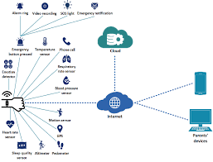

**Reference: https://www.verypossible.com/insights/top-problems-when-iot-products-hit-real-world**